Airbag system deployment

I would be developing a car airbag as my safety critical example. My program is meant to

demonstrate when different factors occur different airbag configurations are tiggered. During a

crash the airbag electronic controller unit (ECU) will look at the collision type (speed), angle, and

severity of impact and will decide on whether the airbags should be deployed.

Parameters (functional safety requirements)

Collision type, speed: such as United States regulations require deployment in crashes to be 23 km/h

as the threshold for the airbag to deploy.

Angle: For some higher end cars more airbags are fitted in the car not just the front. Higher end cars

such as Mercedes and BMW’s have side airbags fitted. To make my system more complex I will aim

to model a higher end car with side airbags.

Temperature: Nearly all airbags are designed to automatically deploy in the event of a vehicle fire

when temperatures reach 150–200 °C. This safety feature, often termed auto-ignition. I will set my

temperature requirement for deployment at 150°C.

Simple idea of my system is to look at when to deploy the airbag and when not to. Above are the

parameters for airbag systems and I will model using these variables. All the parameters are

essential in a safety critical system such as an airbag.

Actions

Speed I shall follow the US regulations and if the speed is 23 or higher deploy depending on the

angle of collision.

For the angle it varies on which angle the collision occurs. If hit from a side on angle most new cars

have side on airbags for which if hit on the right the side airbags are deployed. (Side tubular or

curtain airbag). This airbag was designed to offer head protection in side impact collisions and

frontal airbag used for head on collision. I will demonstrate this in my program.

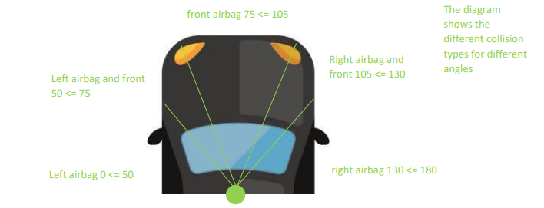

I plan to use the above values and the range from 0 to 180 for the angles as, the car is more of a

semi-circle as you can see from the diagram. I shall incorporate the range and conditions as

modelled above as this seems the most realistic for a critical system.

The action for the temperature is if equal to 150°C or above deploy all airbags, although some cars

have a differing value I have just gone for this constant temperature.

Below is the screenshot of the varying features of the system.

Screenshot 1 shows that if the speed is under 23 and the temp is under 150 no airbags deployed. It

also shows the condition for when complete inputs it asks if you want to continue.

